­ Bahria University,

Karachi Campus

LAB EXPERIMENT NO.

**08**

LIST OF TASKS

|  |  |
| --- | --- |
| TASK NO | OBJECTIVE |
|  | FOR LOOP CONTROL STRUCTURE IN MIPS |
| 1 | Write a program in MIPS assembly language that takes input and display whether number is prime or not. |
| 2 | Write a program in MIPS assembly language that provide the sum from 1 to 99 using for Loop |
| 3 | Print the table .(Example) |
| 4 | Print numbers 1to 10 through increments. .(Example) |
| 5 | Print numbers 1to 10 through Decrement. .(Example) |

Submitted On:

7/12/2022

(Date: DD/MM/YY)

**TASK NO 1**: Write a program in MIPS assembly language that takes input and display whether number is prime or not.

**SOLUTION:**

.data

promt:.asciiz"Enter Your Number : "

prime:.asciiz"Prime Number "

notprime:.asciiz"Not Prime Number"

.text

**OUTPUT**

.globl main

main:

addi $t4,$zero,0

addi $t5,$zero,1

li $v0,4

la $a0,promt

syscall

li $v0,5

syscall

move $t0,$v0

li $t1,2

start:

bgt $t1,$t0,decide

div $t0,$t1

mflo $t2

mfhi $t3

beqz $t3,count

decide:

bge $t4,2,notprimeme

addi $t1,$t1,1

bge $t3,$t5,start

b primenumber

count:

addi $t4,$t4,1

addi $t1,$t1,1

b start

primenumber:

li $v0,4

la $a0,prime

syscall

b exit

notprime:

li $v0,4

la $a0,notprime

syscall

b exit

exit:

li $v0,10

syscall

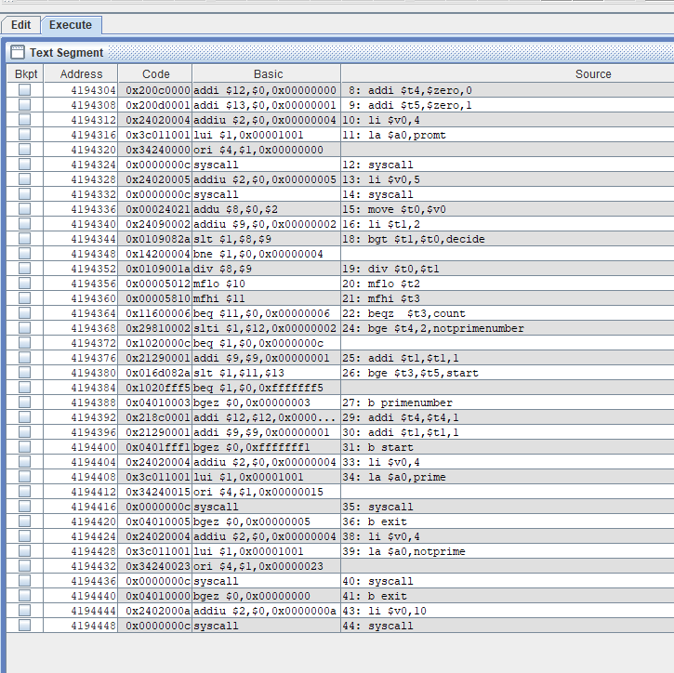

**TASK NO 2**: Write a program in MIPS assembly language that provide the sum from 1 to 99 using for Loop

**SOLUTION:**

.data

prompt: .asciiz "Enter Any Number : "

tab1: .asciiz "\n"

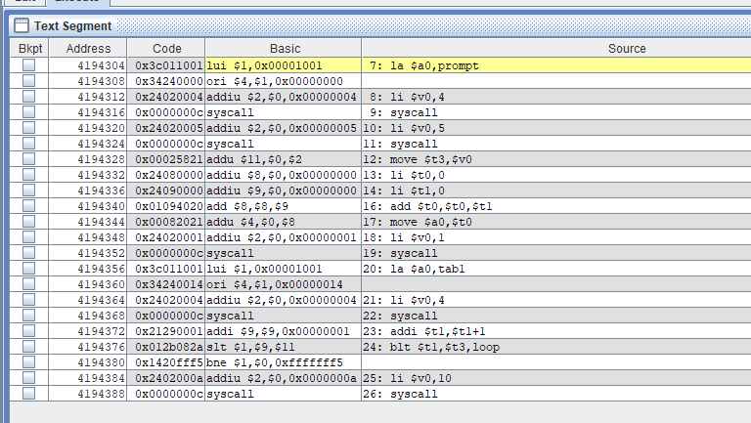

.text

.globl main

main:

la $a0,prompt

li $v0,4

syscall

li $v0,5

syscall

move $t3,$v0

li $t0,0

li $t1,0

loop:

add $t0,$t0,$t1

move $a0,$t0

li $v0,1

syscall

la $a0,tab1

li $v0,4

syscall

addi $t1,$t1+1

blt $t1,$t3,loop

li $v0,10

syscall

**OUTPUT:**

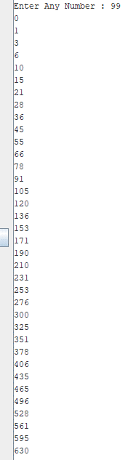





**EXAMPLE**: Write a program in MIPS assembly language that print table.

**SOLUTION:**

**.**data

prompt: .asciiz "Enter lenght for table: "

prompt1: .asciiz "Enter table : "

tab: .asciiz "*2 = "

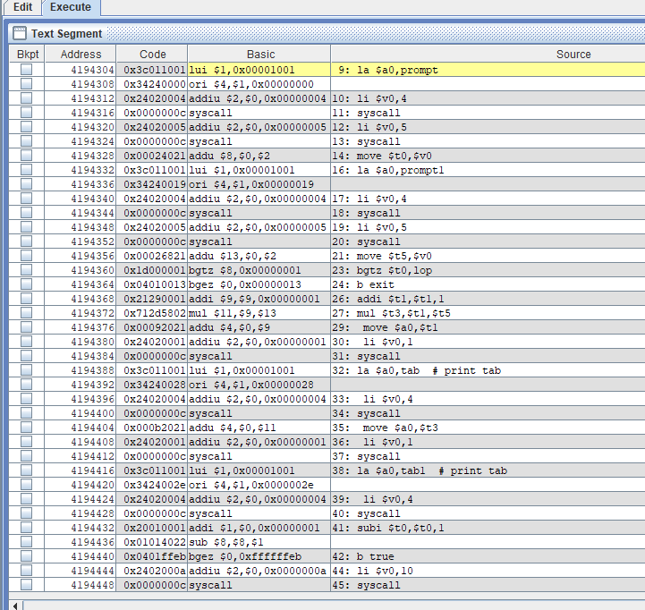

tab1: .asciiz "\n"

.text

.globl main

main:

la $a0,prompt

li $v0,4

syscall

li $v0,5

syscall

move $t0,$v0

la $a0,prompt1

li $v0,4

syscall

li $v0,5

syscall

move $t5,$v0

true:

bgtz $t0,lop

b exit

lop:

**OUTPUT:**

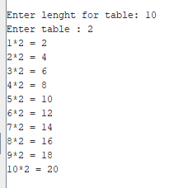

addi $t1,$t1,1

mul $t3,$t1,$t5

move $a0,$t1

li $v0,1

syscall

la $a0,tab # print tab

li $v0,4

syscall

move $a0,$t3

li $v0,1

syscall

la $a0,tab1 # print tab

li $v0,4

syscall

subi $t0,$t0,1

b true

exit:

li $v0,10

syscall

**EXAMPLE** : Print numbers 1to 10 through increments.

**SOLUTION:**

.data

p: .asciiz "\n"

.text

.globl main

main:

#user input

li $v0,5

syscall

move $t0,$v0

# alt li $t0,10

loop:

la $a0,p

**OUTPUT:**

li $v0,4

syscall

bgtz $t0,true

b exit

true:

addi $t1,$t1,1

move $a0,$t1

li $v0,1

syscall

#decrement

subi $t0,$t0,1

b loop

exit:

li $v0,10

syscall

**EXAMPLE** :Print numbers 10 to 1 through Decrement.

**SOLUTION:**

.data

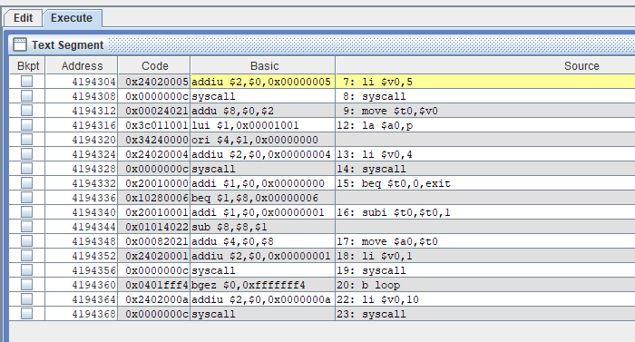

p: .asciiz "\n"

.text

.globl main

main:

#user input

li $v0,5

syscall

move $t0,$v0

# alt li $t0,10

loop:

la $a0,p

li $v0,4

syscall

beq $t0,$zero,exit

subi $t0,$t0,1

move $a0,$t0

li $v0,1

syscall

b loop

exit:

li $v0,10

syscall

**OUTPUT**:

